# Report on VPN (Task 2)



**Name** Aravindh JAWAHAR

**Formation** MSS September 2021

**Task N°** 2

**Problem statement:**

In this lab, we will create a webserver and a PKI to generate a self-signed certificate. One CentOS 8 virtual machine will be used. A minimal configuration is enough and only 2GB of RAM and 2 CPU’s are needed.

**Index**

Installing webserver ………………………………………………………………………………………………………………2

Accessing webserver …………………………………………………………………………………………………………….3

Generating self-signed certificates ……………………………………………………………………………………….3

Conclusion ……………………………………………………………………………………………………………………………4

**Solution:**

CentOS 8 has been installed on VMWare workstation player 16.

**Installing Webserver:**

Apache server has been installed on the VM using the command:

Yum install httpd -y



And the server has been enabled to start the service with the command:

**Systemctl start httpd Systemctl enable httpd**

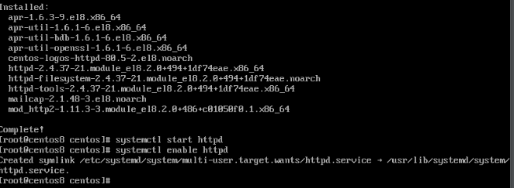

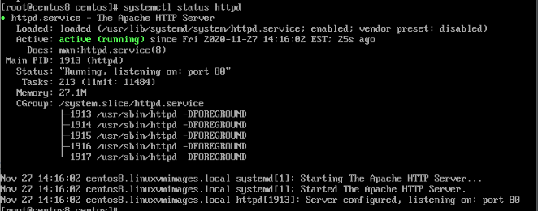

**Accessing Webserver:**

Then the server can be accessed using the **browser** with the help of the **IP** **address** of the browser. The link to access the server of apache in the browser is <http://192.168.132.180>. This link has no certificate for encryption so that our task is to enable encryption on the access over the web interface for the apache server by providing the certificates enabling for the access.

**Generating self-signed certificates:**

The following are the steps to achieve the encryption:

1. Install openssl to create certificate
2. Verify whether the module has been installed
3. Create the certificate:

Create new directory and type the following command:

**openssl req -x509 -nodes -newkey rsa:2048 -keyout lab.local.key -out lab.local.crt**

1. Configure the web server on **ssl.conf** file on **/etc/httpd/conf.d/** and verify the details

Check the server access with the link along side containing the certificates and check it:

<https://192.168.182.130>

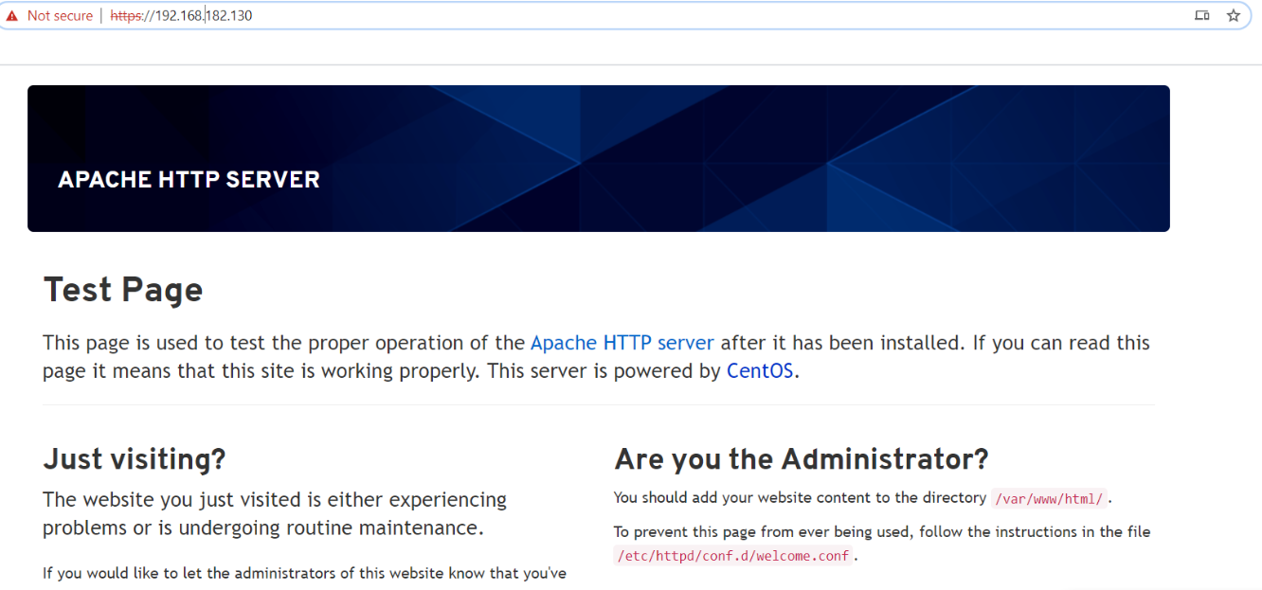

Use the command **tcpdump -i any icmp**  to verify whether the traffic is encrypted

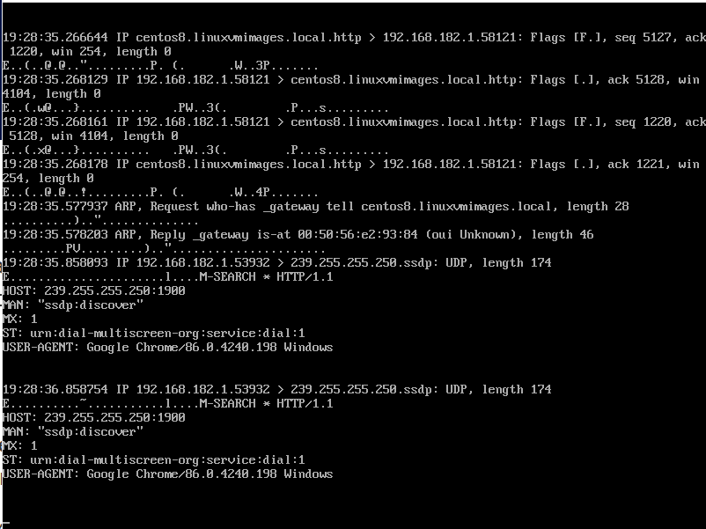

**Conclusion:**

Thus, we created a web server in CentOS 8 and used PKA to generate the self-signed certificates